# Open Database file;

1. I use a program called DB Browser for SQLite. Open database file ‘Crystals.db’.
2. Select the ‘Browse Data’ tab;  
   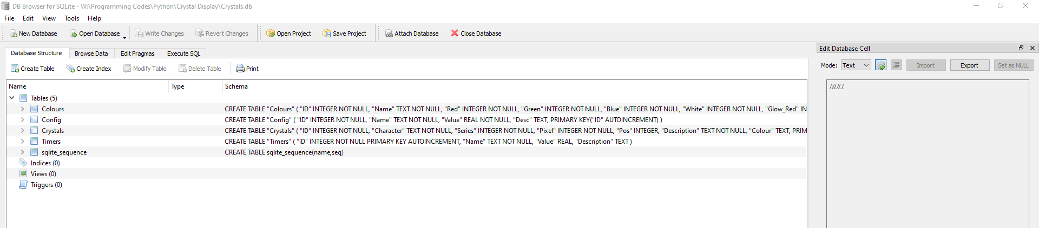

# Editing Crystals information;

1. Select the ‘Crystals’ table from the drop down list;  
   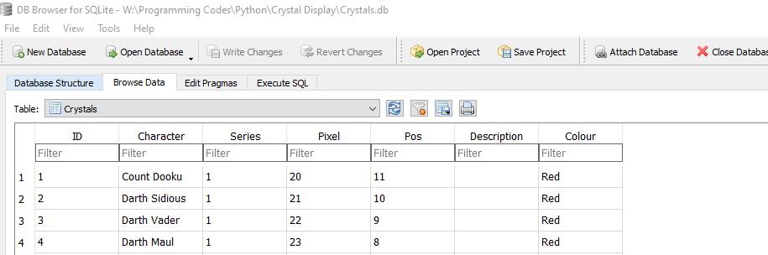
2. ***DO NOT CHANGE THESE COLUMNS;***
   1. ID
3. You can update the Character coloumn, this will update the name displayed on the touch screen.
4. You can update Series, this will update the series number displayed on the touch screen.
5. Pixel is the position in the Neo Pixel chain (first pixel, nearest the R-pi, is zero). This will vary depending on how you wire up the electronics.
6. Pos is the order the buttons will appear on the screen. Position 0 is the top left, and they increase going left to right and then top to bottom. So bottom right his the highest position.
7. Description column is the text displayed when a button is pressed. I have prefilled out series 2 crystals with the text on the slips that came with the crystals.
8. Colour is the colour the button/Neo Pixels will glow. Only the following colours will work;
   1. Red
   2. Blue
   3. Green
   4. Yellow
   5. White
   6. Black
   7. Purple

# Editing Config Settings;

1. Select ‘Config’ from the drop down tables list (see above section).
2. ***DO NOT CHANGE***  these columns;
   1. ID
   2. Name
3. The Desc column is an unused column just for me to describe what each row is for.
4. You can update the Value column to customise your setup to how you like;
   1. GPIO Pin – this is the pin you have the communications for the pixels connected to. Options are (I use pin 12);
      1. 10
      2. 12
      3. 18
      4. 21
   2. Random Crystal Pulses – how many times you would like the crystals to go from idle to full brightness for the random crystal sequence, as well as when a button is pressed.
   3. Illuminate buttons – 1= on, 2= off. This will enable or disable the buttons from lighting up during the sequences. They will still light up with button presses, even when set to 0.
   4. Max Buttons is the maximum number of buttons in a row. I would recommend having this match how you have the crystals displayed, as this will impact the sequences.
   5. Brightness is how bright you want the crystals to display. This is a percentage so 0 is off, 1 is max brightness. Default value is 0.8.

# Editing Colours Settings;

1. Select ‘Colours’ from the drop down tables list (see above section).
2. ***DO NOT CHANGE***  these columns;
   1. ID
   2. Name
3. You can update the Value column to customise your setup to how you like;
   1. Red – this is the RGBW value for the red part when at maximum brightness (peak of the pulsing). Set between 0 and 255. I have optimised this value based on my setup.
   2. Green – this is the RGBW value for the green part when at maximum brightness (peak of the pulsing). Set between 0 and 255. I have optimised this value based on my setup.
   3. Blue – this is the RGBW value for the blue part when at maximum brightness (peak of the pulsing). Set between 0 and 255. I have optimised this value based on my setup.
   4. White – this is the RGBW value for the White part when at maximum brightness (peak of the pulsing). Set between 0 and 255. I have optimised this value based on my setup.
   5. Glow_Red – this is the RGBW value for the red part when at background glow (normal glow when not pulsing). Set between 0 and 255 . I have optimised this value based on my setup.
   6. Glow_Green– this is the RGBW value for the green part when at background glow (normal glow when not pulsing). Set between 0 and 255 . I have optimised this value based on my setup.
   7. Glow_Blue – this is the RGBW value for the blue part when at background glow (normal glow when not pulsing). Set between 0 and 255 . I have optimised this value based on my setup.
   8. Glow_White – this is the RGBW value for the white part when at background glow (normal glow when not pulsing). Set between 0 and 255 . I have optimised this value based on my setup.

# Editing Timers Settings;

1. Select ‘Timers’ from the drop down tables list (see above section) All timers are set in seconds.
2. ***DO NOT CHANGE***  these columns;
   1. ID
   2. Name
3. The Desc column is an unused column just for me to describe what each row is for.
4. You can update the Value column to customise your setup to how you like;
   1. The stages rows are the times between each stage of the sequence. I.e. when the next set of Neo Pixels start their sequence, e.g. for a top left corner; stage 1= position 0, stage 2 = positions 1,7,8. I have optimised these values based on my setup.
   2. The pulses rows are the times between each tick of pulses. Lower value means the lights pulse quicker. Most colours have 200+ ticks to full brightness and 255 ticks to return to black (in the button colour).

# Editing the Sequences Table

1. Select ‘Sequences’ from the drop down tables list (see above section) All timers are set in seconds.
2. ***DO NOT CHANGE***  these columns;
   1. ID
   2. Name
   3. Routine
3. The Desc column is an unused column just for me to describe what each row is for.
4. This table allows you to turn on or off the different sequences the lights can run, 1=on, 0=off in the Enable column. This is to allow you to customise the display how you want. If you don’t like a certain pattern, you can stop it from running here.